INVENTION DISCLOSURE FORM
Confidential & Attorney-Client Privileged
Applicant Name: SR University
SR University, Ananthsagar, Hasanparthy (M), Warangal Urban, Telangana - 506371

1. Particulars of Inventors
Title | Name (Full) | Department | Designation | Mobile No. | Email | Postal Address
Mr. | Naresh Kumar Sripada | CS & AI | Asst. Professor | 9866000203 | Naresh22.in@gmail.com | SR University, Ananthsagar, Hanamkonda
Mr. | Burra Praneeth | CS & AI | Student | 9515692690 | burrapraneeth007@gmail.com | SR University, Ananthsagar, Hanamkonda
Mr. | Zaid Khizar | CS & AI | Student | 9676007348 | Zaidkhizar1226@gmail.com | SR University, Ananthsagar, Hanamkonda
Mr. | Nithin Varma | CS & AI | Student | 9398288263 | nithinvarmanampally@gmail.com | SR University, Ananthsagar, Hanamkonda
Mr. | Macharla  Goutham | CS & AI | Student | 9177902005 | gouthammacharla2005@gmail.com | SR University, Ananthsagar, Hanamkonda

2. Provide a brief descriptive title of the invention:
A Computer-Implemented System and Method for Time-Series Forecasting of Screen Time and Mobile Application Usage Behavior Using an Intelligent Multi-Model Fusion Deep Learning Framework

3. In 100 words or less, please provide an abstract or summary of the invention:
The present invention proposes a computer-implemented system for forecasting screen time and mobile application usage behavior using a multi-model fusion deep learning approach. The system utilizes time-series data and integrates Convolutional Neural Networks (CNN), Long Short-Term Memory (LSTM), and Gated Recurrent Units (GRU) to capture both temporal and behavioral patterns. A fusion layer combines outputs from these models to enhance prediction accuracy. The system enables intelligent prediction of future screen usage, providing insights for digital wellbeing, productivity enhancement, and behavioral monitoring. The proposed approach improves efficiency compared to traditional single-model methods.

4. Detail Description of the Invention:
(Answer to all below are required in detail)

- Problem the Invention is Solving

Smartphones have become an essential part of daily life for communication, education, work, and entertainment. However, excessive screen time has created serious issues such as reduced productivity, poor concentration, sleep disturbance, and digital addiction. Existing applications such as Screen Time and Digital Wellbeing only provide historical usage statistics and reports. They do not predict future usage behavior or provide proactive solutions.
The major limitations in existing systems are as follows:
• Existing tools only show past usage data and cannot forecast future screen time.
• Alerts are generated only after overuse has already happened.
• Traditional forecasting models such as ARIMA and linear regression cannot capture complex behavioral patterns.
• Single AI models do not learn all types of temporal dependencies effectively.
• Current systems do not consider contextual factors such as weekdays, weekends, app category, or user habits.
• No intelligent unified system exists for accurate screen time prediction using multiple deep learning models.
Therefore, there is a need for an advanced forecasting system that can analyze historical mobile usage data and accurately predict future screen time and app usage behavior.

b. General Utility / Application of the Invention

The present invention can be used in several domains where monitoring and controlling digital behavior is important.
• Digital Wellbeing: Predict excessive usage and recommend healthy breaks.
• Productivity Management: Help users reduce distractions and improve focus.
• Parental Control: Alert parents about future overuse by children.
• Healthcare: Support monitoring of digital addiction and mental wellness.
• Enterprise Analytics: Track productivity trends of employees.
• Education: Help students manage study time and reduce unnecessary phone usage.
• Research: Useful for studies related to digital behavior and user analytics.
Thus, the invention has applications in personal, academic, healthcare, and business environments.

- Advantages of the Invention

The invention offers several advantages over traditional monitoring and forecasting methods.
• Higher prediction accuracy using CNN, LSTM, and GRU fusion.
• Learns both short-term and long-term user behavior patterns.
• Provides proactive alerts before excessive usage occurs.
• Can include contextual features for better predictions.
• Supports retraining when user habits change over time.
• Can be deployed on mobile devices, cloud platforms, or enterprise systems.
• Improves productivity and promotes healthier digital habits.
• Flexible design allows future upgrades with new AI models.
These advantages make the proposed system more effective than existing screen time monitoring solutions.

d. Best Way of Using the Invention as well as Possible Variants

Best Mode Implementation

Hardware:
• Smartphone or device generating usage logs
• Computer / cloud server for training and deployment
• Internet connectivity for cloud-based systems

Software:
• Python
• TensorFlow / Keras
• Pandas, NumPy, Scikit-learn
• Matplotlib / Seaborn
• Google Colab / CUDA GPU

Working Method:
• Collect screen time and app usage data
• Preprocess and normalize the dataset
• Create time-series sequences using sliding windows
• Train CNN, LSTM, and GRU models
• Combine outputs using fusion layer
• Predict future screen time
• Display results through dashboard or mobile app

Possible Variants
• Add Transformer-based models
• Use federated learning for privacy
• Deploy on-device using TensorFlow Lite
• Add smartwatch or calendar data
• Extend to desktop screen usage prediction

e. Working of Invention along with Drawings, Schematics and Flow Diagrams
The invention works in the following stages:

Step 1 – Data Collection:
Collect screen time logs, app usage duration, and timestamps from the device.
Step 2 – Preprocessing:
Clean the data, normalize values, encode categories, and generate time-series sequences.
Step 3 – Parallel Model Learning:
The same input is given to three models: CNN, LSTM, and GRU.
Step 4 – Fusion Layer:
Outputs of all three models are combined using an intelligent fusion mechanism.
Step 5 – Prediction Output:
The final dense layer predicts future screen time and app usage values.
Step 6 – Feedback System:
Predictions are shown to the user through dashboard alerts, reports, and wellbeing suggestions.

Step 1 - Data Collection:
The system collects three streams of data from the user device: Screen Time Data, App Usage Logs (timestamp, app_id, duration), and Interaction Events. These raw event tuples are aggregated in the Data Collection module as depicted in Figure 1.

Step 2 - Preprocessing and Feature Engineering (Figure 3 & Figure 13):
Raw usage logs are resampled and aggregated into 15-minute unified time intervals. Contextual features are extracted including Day of Week, Hour of Day, and App Category (Social, Game, Productivity, etc.). Data is normalized using Min-Max or Z-Score normalization. A sequential sliding window generation step produces model-ready feature tensors of dimension (T, F, C) representing Time steps, Features, and Channels respectively.

Step 3 - Multi-Model Parallel Training (Figure 2 & Figure 4-6):
The input feature tensor (T, F, C) is fed simultaneously to three parallel deep learning architectures:
- 1D-CNN Model (Figure 4): Applies 1D convolutional layers with kernels of varying sizes (1x1, 3x3, 5x5) along the time axis, followed by max-pooling layers, to extract local temporal patterns and spatial features. The output feature map is flattened for fusion.
- LSTM Model (Figure 5): Stacked LSTM cells process the input sequence step-by-step, maintaining a cell state (C_t) and hidden state (H_t) to learn long-term temporal dependencies across the usage time series.
- GRU Model (Figure 6): Gated Recurrent Unit cells with reset and update gates efficiently model short-term behavioral dynamics with lower computational overhead than LSTM.

Step 4 - Multi-Model Fusion (Figure 7):
The flattened CNN feature vector, the last LSTM hidden state, and the last GRU hidden state are combined in the Multi-Model Fusion Node. The fusion mechanism applies learned weights (w1, w2, w3) via weighted averaging or concatenation to produce a Post-Fusion Feature Vector, which is passed through a Dense Prediction Network (fully connected layers with dropout) to generate the Final Usage Forecast Vector.

Step 5 - Context-Aware Prediction Module (Figure 9):
The fused behavior vector is enriched with User Profile Embeddings (age, occupation, usage context) and External Context Embeddings (day-of-week, location, calendar, holidays) through a Contextual Embedding and Attention Layer. The Prediction Output Network then generates Context-Refined Multi-Horizon Forecasts (e.g., screen time for next 24 hours, next 7 days).

Step 6 - Well-Being Feedback and User Interface (Figure 11):
The system delivers real-time usage forecasts and actionable digital well-being suggestions through the Well-Being Coach App interface. When a predicted usage spike is detected, the system recommends scheduling a Digital Wellbeing Break, which can be added to the user's calendar. User acceptance or rejection of suggestions forms an Adaptive Learning Signal that feeds back into model retraining.

Step 7 - Adaptive Re-Training (Figure 15):
A model performance monitoring module continuously compares predicted usage against actual usage logs, computing MAE/RMSE drift scores. When a drift threshold is exceeded, a re-training trigger signal is issued. The Adaptive Re-Training Module retrains the CNN/LSTM/GRU fusion using recent usage tensors blended with historical core patterns, and pushes updated model weights to the deployed operational model.

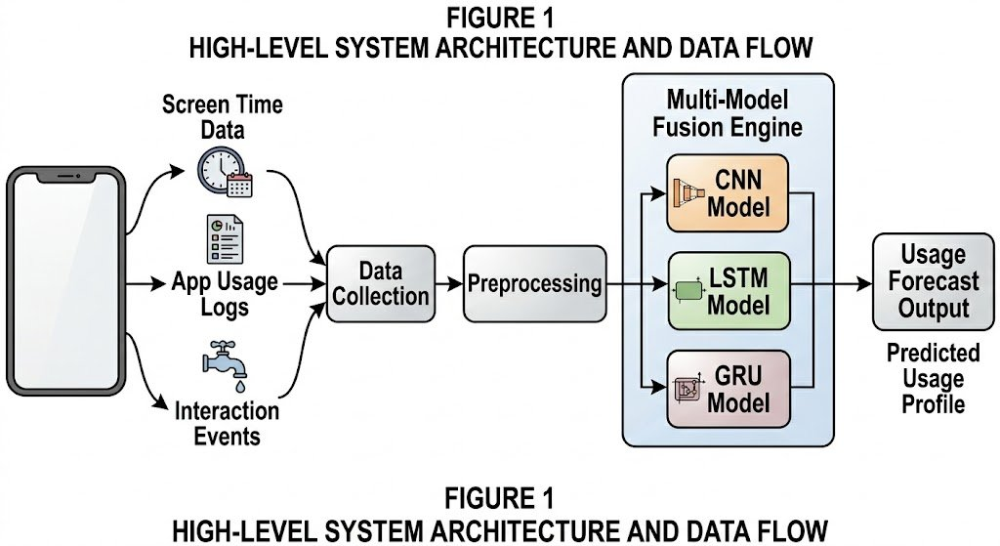
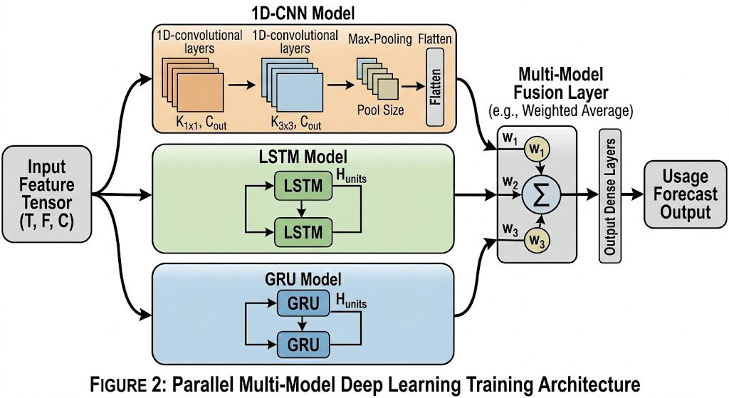
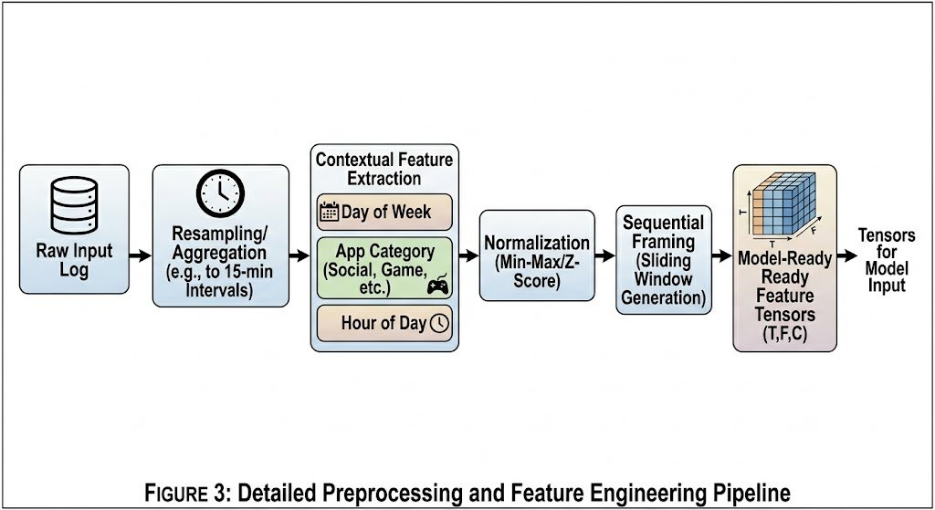
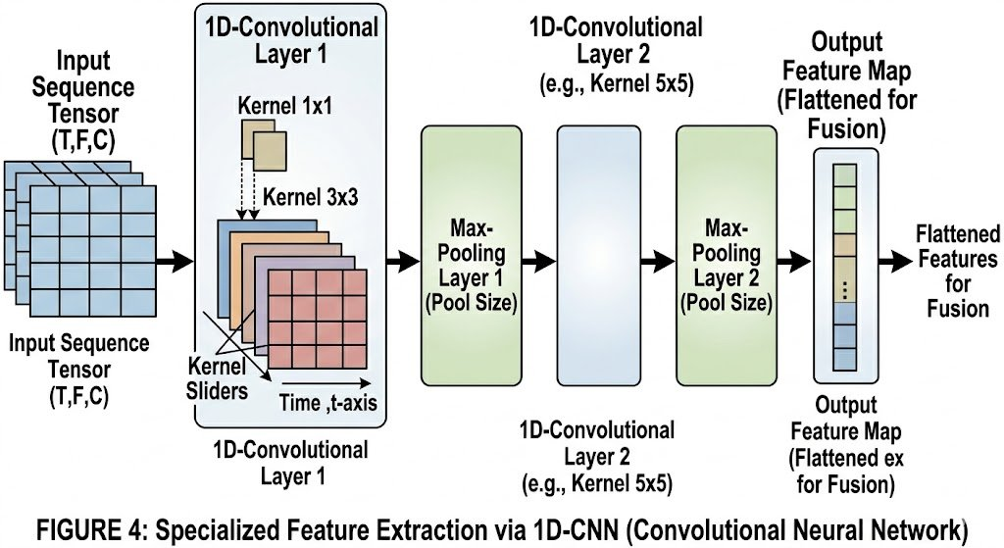
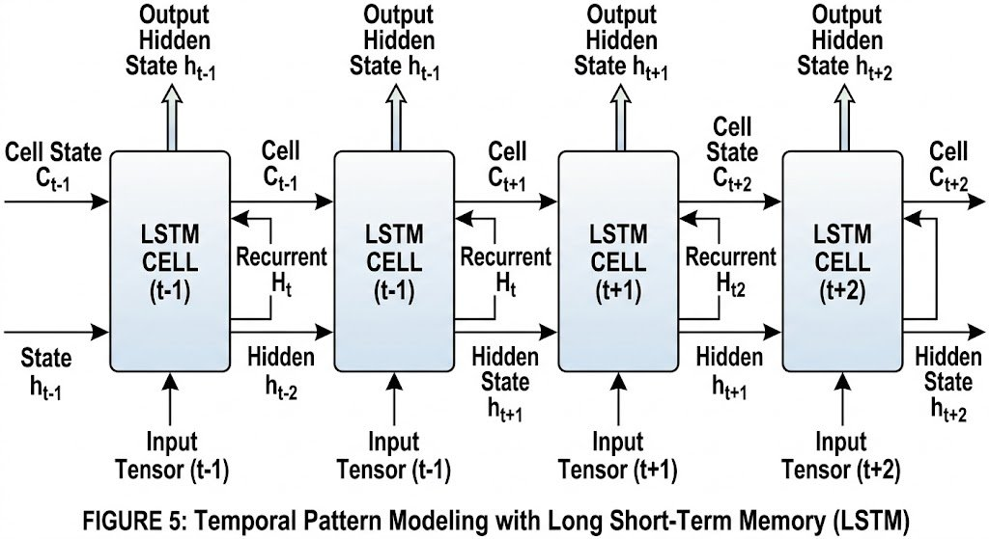
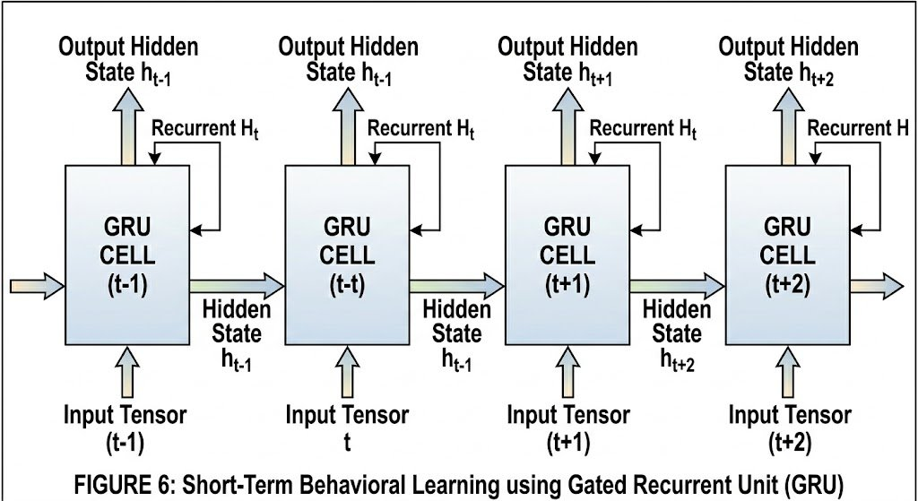
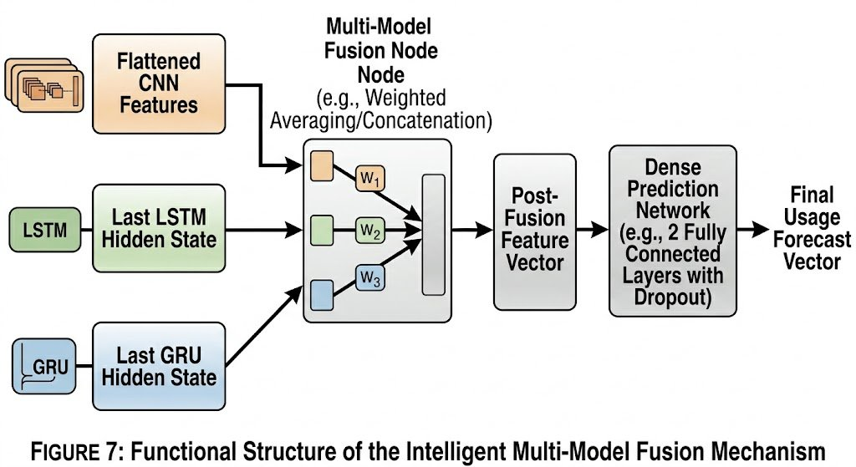
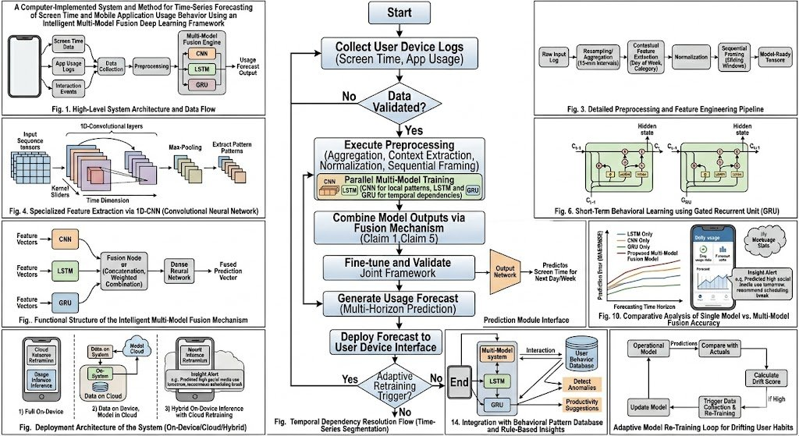
Figure 8: Complete System Flowchart - End-to-End Processing Pipeline

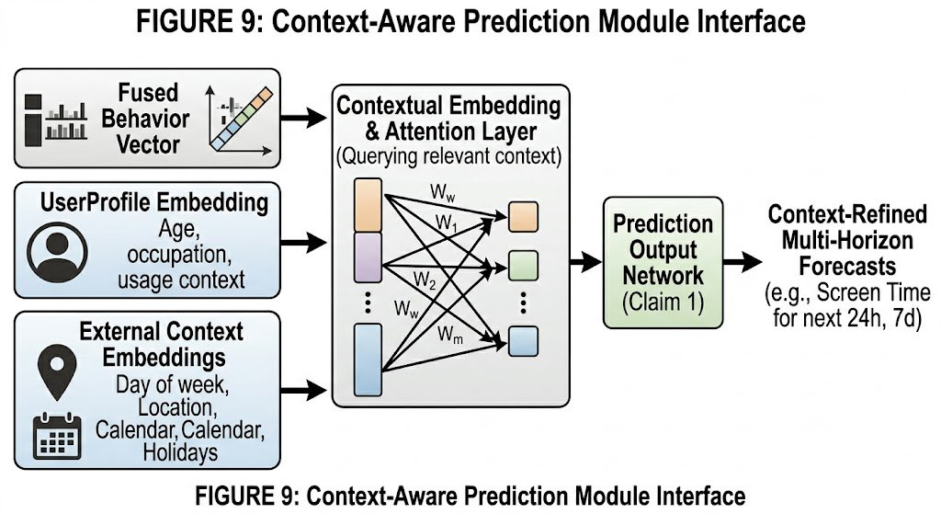
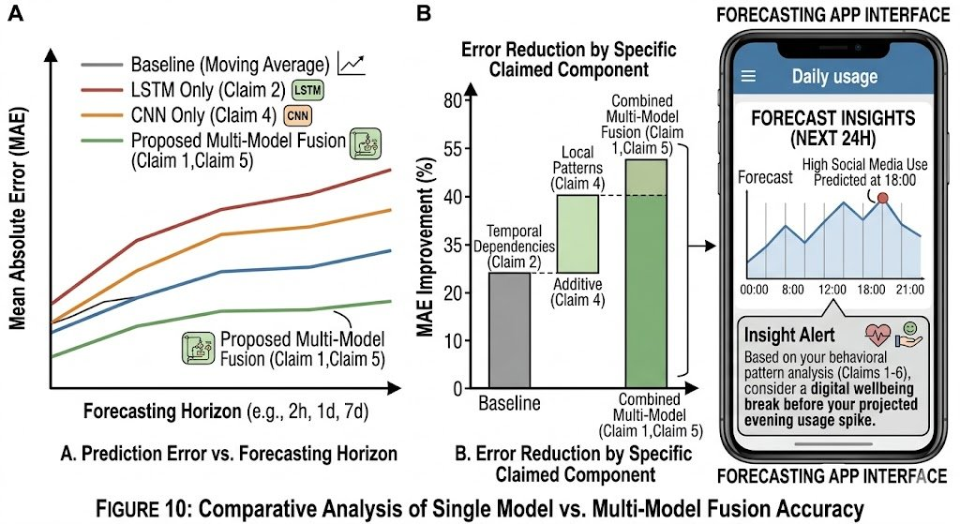
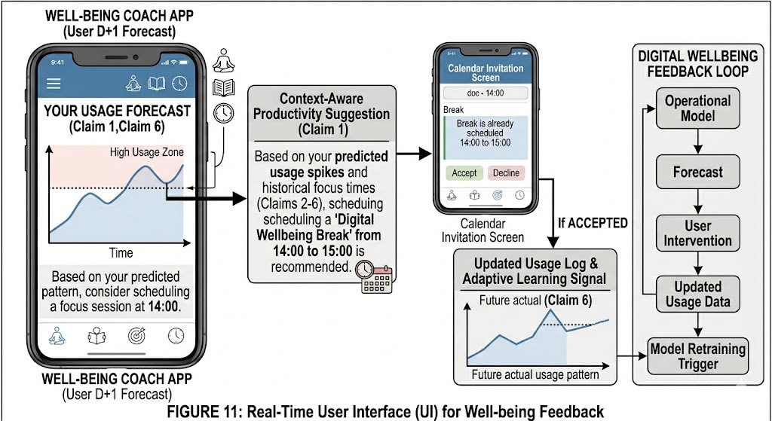

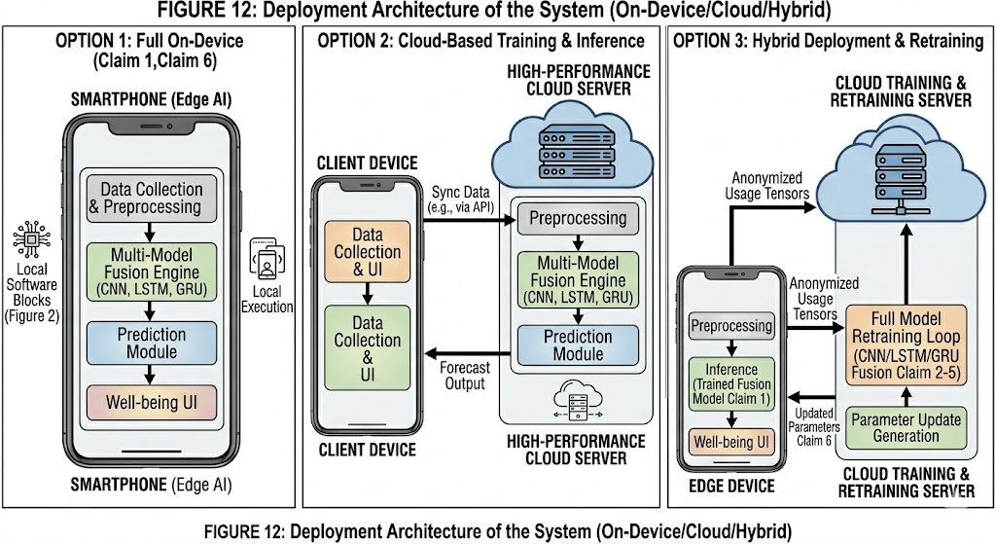
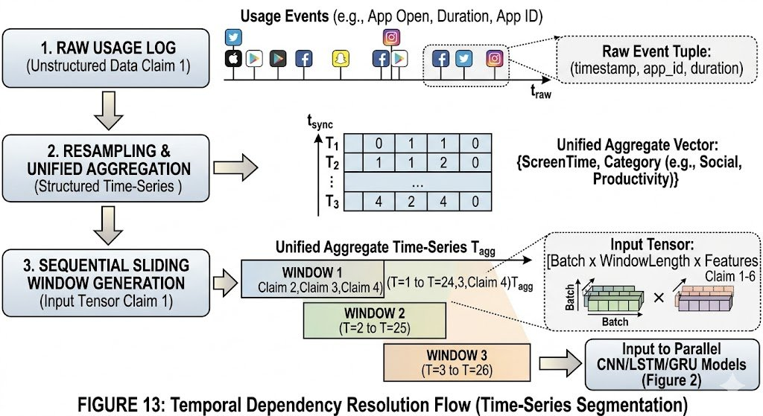
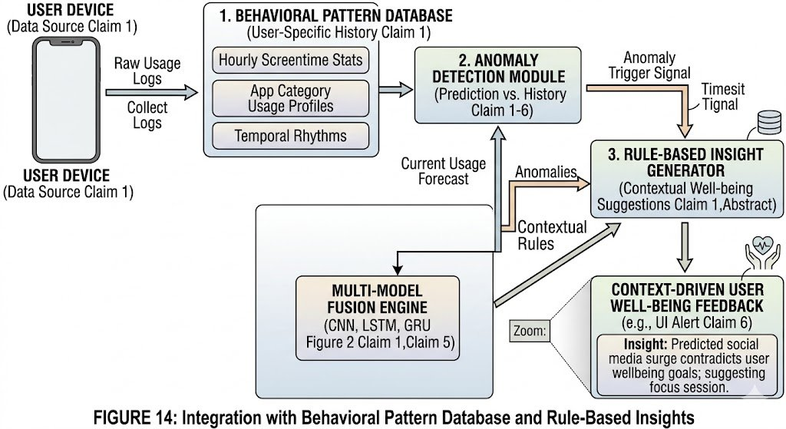
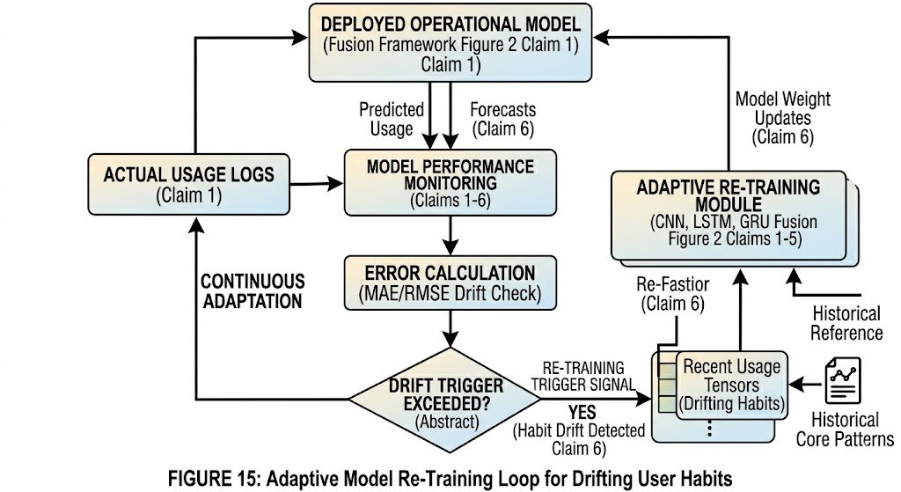

5. Primary Patent Search
A primary patent search has been conducted. Relevant prior art was reviewed from USPTO, EPO, and Google Patents databases. No exact prior art was identified that discloses the specific combination of parallel CNN, LSTM, and GRU with an intelligent multi-model fusion layer applied specifically to mobile screen time and app usage behavior forecasting. Search report to be attached separately.

6. Existing State-of-the-Art and Prior Art
- Basic screen time monitoring applications: Apple Screen Time, Google Digital Wellbeing - provide only historical usage dashboards without predictive capabilities
- Statistical time-series methods: ARIMA, SARIMA, Exponential Smoothing - limited to linear, stationary signals and unable to model complex behavioral dynamics
- Single deep learning models: standalone LSTM or CNN applied to activity recognition or general time-series forecasting tasks, but not specifically to screen time prediction with multi-model fusion
- Simple machine learning classifiers: SVM, Random Forest used for app usage classification with limited temporal modeling capability
- Rule-based parental control systems: enforce static usage caps without personalized prediction

7. Comparison with Existing Systems

S.No. | Existing System | Drawbacks | How Our Invention Overcomes It
1 | Screen Time Apps (e.g., Digital Wellbeing, Screen Time on iOS) | Only provide historical usage statistics; no predictive capability | Adds multi-step forecasting of future screen time and app usage, enabling proactive interventions
2 | Traditional ML Models (e.g., Linear Regression, SVM) | Poor accuracy on non-linear, temporal behavioral data; limited feature learning | Multi-model deep learning fusion captures non-linear temporal patterns with significantly higher accuracy
3 | Single Deep Learning Models (standalone LSTM or CNN) | Each model captures only one aspect: temporal or spatial; limited predictive power | Parallel CNN + LSTM + GRU fusion captures both local patterns and long/short-term temporal dependencies simultaneously
4 | Statistical Time-Series Methods (ARIMA, SARIMA) | Assume stationarity and linearity; cannot model complex behavioral dynamics | Deep learning fusion handles non-stationary, multi-variate behavioral signals with contextual feature embedding

8. Technical Features and Elements of the Invention
- Time-series dataset processing pipeline: raw log ingestion, resampling to 15-minute intervals, unified aggregation
- Contextual Feature Extraction module: Day-of-Week encoding, Hour-of-Day encoding, App Category embedding
- Normalization module: Min-Max scaling and Z-Score normalization for stable model training
- Sequential Sliding Window Generator: produces overlapping (T, F, C) tensors for supervised sequence learning
- 1D-Convolutional Neural Network (CNN) branch: two 1D-conv layers with variable kernel sizes and max-pooling for local pattern extraction
- Long Short-Term Memory (LSTM) branch: stacked LSTM layers with cell-state and hidden-state propagation for long-term dependency modeling
- Gated Recurrent Unit (GRU) branch: stacked GRU layers for efficient short-term behavioral pattern learning
- Multi-Model Fusion Layer: weighted averaging or concatenation of CNN, LSTM, and GRU outputs with learnable fusion weights
- Dense Prediction Network: fully-connected layers with dropout for regularized final forecast generation
- Context-Aware Prediction Module: attention-based contextual embedding of user profile and external signals
- Behavioral Pattern Database: stores hourly screen time stats, app category profiles, and temporal rhythms per user
- Anomaly Detection Module: compares live forecasts against historical behavioral baselines to detect deviations
- Rule-Based Insight Generator: generates contextual well-being suggestions based on detected anomalies
- Adaptive Re-Training Module: MAE/RMSE drift monitoring with automatic retraining trigger and weight update pipeline
- Flexible Deployment Architecture: supports full on-device (Edge AI), cloud-based, and hybrid (on-device inference + cloud retraining) deployments

9. Novel Features of the Invention
- Simultaneous parallel execution of CNN, LSTM, and GRU deep learning models on the same mobile usage time-series input, which has not previously been applied to screen time forecasting
- Intelligent Multi-Model Fusion Mechanism with learned weighted combination (w1, w2, w3) that adaptively balances contributions from spatial, long-term temporal, and short-term temporal models
- Integration of external contextual embeddings (calendar, location, user profile) into a unified attention-based prediction layer tailored for behavioral usage forecasting
- End-to-end adaptive retraining pipeline that detects user habit drift via statistical drift scores and automatically updates model parameters without user intervention
- Unified system that spans data collection, preprocessing, multi-model training, fusion, prediction, user-facing well-being feedback, and adaptive retraining in a single deployable framework

10. Implementation Details
The invention has been implemented and tested with the following technical stack:
- Programming Language: Python 3.x
- Deep Learning Framework: TensorFlow 2.x / Keras API
- Data Processing Libraries: NumPy, Pandas, Scikit-learn
- Dataset: Mobile usage dataset sourced from Kaggle (screen time and app usage logs)
- Training Platform: GPU-accelerated environment (Google Colab / local CUDA setup)
- Evaluation Metrics: Mean Absolute Error (MAE) and Root Mean Square Error (RMSE) across 2-hour, 1-day, and 7-day forecast horizons
- First successful implementation and testing completed during academic research at SR University, Department of CS & AI

11. Idea Conception
The invention was conceived during academic research on mobile screen time analysis and digital wellbeing at SR University. The inventor observed that while screen time monitoring tools were widely available, none offered predictive capabilities. The gap between retrospective analysis and proactive behavioral forecasting motivated the design of a multi-model deep learning fusion architecture specifically tailored to time-series usage data.

12. Prior Disclosure
No public sale, offer for sale, public use, or publication related to this invention has been made prior to this submission. No individuals outside the immediate research team have been disclosed the details of this invention. No non-disclosure agreements have been required to date. The inventors are not aware of any specific statutory bar deadlines at this time but request the filing process be initiated promptly to preserve international filing options.

13. Non-Obviousness
The invention is non-obvious to a person of ordinary skill in the art for the following reasons:
- While individual models such as LSTM, CNN, and GRU are known for time-series forecasting, their specific combination in a parallel fusion architecture applied to mobile screen time and per-app usage behavior prediction is not previously documented
- The specific design choice of combining local spatial feature extraction (CNN) with long-term memory (LSTM) and short-term gated dynamics (GRU) through a learned weighted fusion layer represents a non-trivial architectural innovation
- The integration of contextual user profile embeddings and external calendar signals via an attention mechanism into the forecasting pipeline for behavioral digital wellbeing is novel
- The end-to-end adaptive retraining mechanism that triggers on statistically detected behavioral drift and updates fusion model weights without full retraining from scratch is not obvious from existing literature

14. Additional Comments
The invention can be extended in the following directions:
- Mental health monitoring: correlate predicted high-usage periods with self-reported mood or stress indicators to provide mental health insights
- AI-based recommendation systems: suggest alternative productive activities or app replacements based on predicted usage spikes
- Federated learning extension: train the fusion model across multiple user devices without sharing raw behavioral data, preserving user privacy
- Wearable integration: incorporate data from smartwatches or fitness trackers to enrich the contextual feature space
- Enterprise workforce analytics: deploy in organizational settings to monitor and optimize digital productivity patterns across teams
15.Flow Chart / Table of Contents of All Diagrams
Figure | Title | Description
Fig. 1 | High-Level System Architecture | Overall structure of data input, preprocessing, models, fusion, and output
Fig. 2 | Data Collection Process | Collection of screen time, app usage, timestamps from user device
Fig. 3 | Data Preprocessing Pipeline | Missing value handling, encoding, scaling, sequence generation
Fig. 4 | Sliding Window Creation | Conversion of raw time-series data into input-output sequences
Fig. 5 | CNN Feature Extraction | Local pattern extraction using convolutional layers
Fig. 6 | LSTM Model Flow | Learning long-term dependencies in usage behavior
Fig. 7 | GRU Model Flow | Learning short-term behavioral patterns efficiently
Fig. 8 | Feature Fusion Process | Combining CNN, LSTM, and GRU outputs into one vector
Fig. 9 | Prediction Layer | Dense network generating future screen time prediction
Fig. 10 | Training Process | Forward pass, loss calculation, backpropagation, convergence
Fig. 11 | Forecasting & Alert Generation | Predicting overuse and generating suggestions/alerts
Fig. 12 | User Dashboard Flow | Display of history, predictions, and wellbeing tips
Fig. 13 | Model Retraining Cycle | Updating model using new user data periodically
Fig. 14 | Context-Aware Prediction | Adding time/day/category/user context for better accuracy
Fig. 15 | Overall System Workflow | End-to-end complete working of the invention

